**Kitchen Story**

**Developer Name: PUTTA SAI KUMAR**

This document contains contents for:

* Project Description
* Sprint planning
* Flow of the Application
* Core concepts used in project
* Conclusions

**1.Project Description:**

* Kitchen Story is an e-commerce portal that lets people shop basic food items on their website. The website needs to have the following features:
* A search form in the home page to allow entry of the food items to be purchased by the customer.
* Based on item details entered, it will show available food items with price.
* Once a person selects an item to purchase, they will be redirected to the list of available items. In the next page, they are shown the complete breakout of the order and details of the payment to be made in the payment gateway.
* When payment is done, they are shown a confirmation page with details of the order.

**For the above features to work, there will be an admin backend with the following features:**

* Admin login page where admin can change password after login
* A master list of food items available for purchase
* A functionality to add or remove food items.

**2.Sprints planning:**

The project is planned to be completed in 2 sprints.

Tasks assumed to be completed in the sprint are:

· Creating the flow of the application

· Initializing git repository to track changes as development progresses.

· Writing the program to fulfill the requirements of the project.

· Testing the Java program with different kinds of User input

· Pushing code to GitHub

· Creating this specification document highlighting application capabilities, appearance, and user interactions.

**3.Application Flow:**

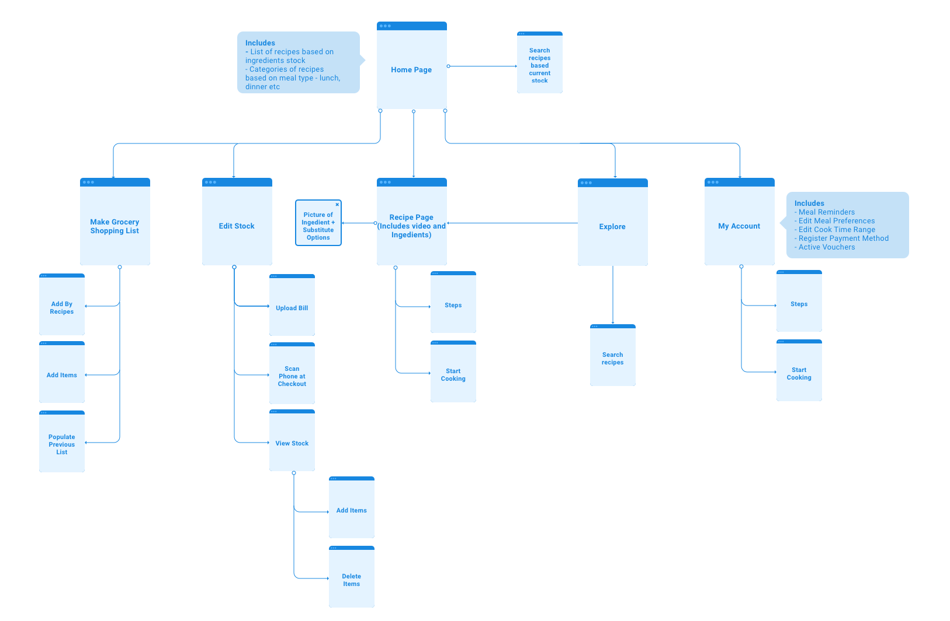

**4.Core concepts used in project:**

* Html
* CSS
* Angular
* Boot strap
* My SQL.

**5.Conclusions:**

This project is designed to create a kitchen story using Angular/bootstrap.